How the western frontiers were won with the help of geophysics

J. G. Smith¹, H. K. Weston²
1) Institute for Historical Geophysics, Houston, Texas, USA
2) School for Military Advances, London, United Kingdom
Correspondence to: J. G. Smith (jgsmith@coldmail.com)

This is the template for preparing a short summary of the oral presentations or posters of the XXX Jornades Eduard Fontserè (23 November 2024).
The extension of the document should be 1-2 pages and it may include figures and a list of references (with DOI), including the article in which the presentation is based.
The documents should be delivered before 5th November 2024.

References
Columbus C, 1492: How I Discovered America. Hispanic Press, Barcelona.
Green RJ, Fred UP, Norbert WP, 1900: Things that go bump in the night, Psych. Today, 46, 345-678.
James K, Harris Jr. G, Wollops W, 1776: American independence and magnetism, Revol. Tracts, 32, 34-55.
Phillips TP, 1999: Possible influence of the magnetosphere on American history, www.sma-london.ac.uk/~phillips/magnet_infl.htm.
Smith JG, Weston HK, 1954: Nothing particular in this year's history, J. Oddball Res., 2, 14-15.

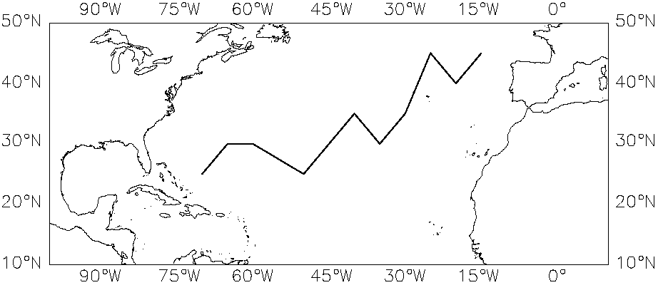

Figure 1. .

